**SERVO MOTOR CONTROLLER**

This is the simple basic design of Servo pulse generator. It uses the CMOS IC 7555 in the Astable mode to generate pulses to drive the servo motor. The circuit can be suitably modified to get pulses of sufficient length.

A Servo is a small device that has an output shaft. This shaft can be positioned to specific angular positions by sending the servo a coded signal. As long as the coded signal exists on the input line, the servo will maintain the angular position of the shaft. The angular position of the shaft is determined by the duration of a pulse that is applied to the control wire. This is called Pulse Coded Modulation.

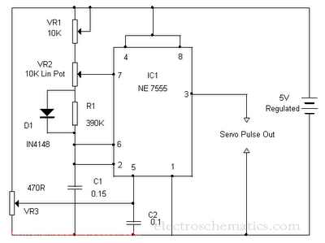

The servo typically requires pulse every 20 milliseconds (.02 seconds). The length of the pulse will determine how far the motor turns. Generally, 1.5 millisecond pulse will make the motor turn to the 90 degree position. This is called the Neutral Position. If the pulse is shorter than 1.5 ms, the motor will turn the shaft to close to 0 degrees. If the pulse is longer than 1.5ms, the shaft turns closer to 180 degrees.

[**M7555Datasheet**](http://electroschematics.com/wp-content/uploads/2010/03/M7555-Datasheet.pdf):  
 The circuit is designed to give control signals to the Servo.IC1 is designed as an Astable multi vibrator which can give pulses for the operation of the Servo. The 10KPot VR2, R1 and capacitor C1 determines the High and Low time of pulses. Since VR2 is variable, High time varies from 2.07 mS to 1.03 mS. The low time will be 40.5 mS. By adjusting VR1, it is easy to get exact timing.VR3 adjust the control voltage of 1.6 volts to the control pin 5 of IC1.

**Servo Motor:**

[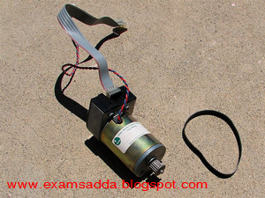](http://1.bp.blogspot.com/-YjiH-khAQPQ/TcfHgEnvrkI/AAAAAAAACVE/kHwX7v5u0pI/s1600/SERVO-MOTOR-2.png)

A control voltage can also be supplied from outside. Then VR3 should be omitted. The control volt can be provided from a variable power supply that gives output of 0-10 volts. The control voltage will control the position of the servo motor connected to the output. When the control voltage changes, the servo will move to the new position corresponding to the new control voltage value. 0 volt causes the servo to remain at one end and 10 volts to other end. If the control volt is 5 volts the servo remains in the center position.